# ECE 162 Week 2 -- The Photocell

Name: Brian Loughran (btl217@lehigh.edu)

## Purpose

The purpose of this lab is to determine the electrical materials properties of a CdS semiconductor in the photocell. For the sake of consistency, the current and voltage will be measured in the dark.

## Theory

Just as samples of different materials, alloys, etc. can display vastly different physical properties (such as density, young’s modulus, specific heat etc.) samples of different materials can display vastly different electrical properties. Some examples of an electrical property are resistance, current density, or drift velocity. In this lab, 5 different electrical materials properties were to be calculated using values for voltage, current, and the dimensions of the semiconductor wire.

The first of the electrical materials properties is the current density (J), which has units of (A/m^2). This can be calculated using the following equation, where I is current with units of (A), and A is the cross sectional area of the semiconductor wire, which has units (m^2)

$$J=\frac{I}{A} (eq 1)$$

The second of the electrical materials properties which was calculated in this lab is the electric field (E), which has units (V/m). It is calculated by dividing current (A) by the length of the semiconductor wire (m). This is shown below in equation 2.

$$E=\frac{V}{L} (eq 2)$$

Another useful electrical materials property which can be calculated with the information already measured is the conductivity (σ) of the wire. The units of conductivity are (1/Ωm).

$$σ=\frac{LI}{VA} (eq 3)$$

If there is current moving through a material, which also means that the electrons are moving through the material. You can calculate the average speed that electrons are moving along the direction of the current. This is called the drift velocity. Usually these numbers are quite small. The equation for the drift velocity includes the mobility of electrons through CdS (μ), which for this lab was assumed to be 2 (cm^2/V-sec). The equation for drift velocity (m/s) is shown below:

$$v=μE (eq 4)$$

Also interesting to note as an electrical materials property is the density of free electrons. This is a measure of how many electrons are flowing per unit volume of wire. If there is any measurable current, there must be many electrons flowing, so one could expect numbers exceeding 1x10^20 for this electrical materials property. Density of free electrons are measured in (electrons/m^3), and the formula is shown below, simplified to take inputs of voltage and current.

$$σ=\frac{IL}{VA} (eq 5)$$

Knowing the mobility of electrons (μ), the physical dimensions of the wire (w, h, L), the voltage (V) and the current (A) all of the five previously mentioned electrical materials properties can be calculated.

## Experimental Method

* Measure with a ruler the width and length of the CdS semiconductor wire. The height is given, and is 20 μm. Using these values, calculate the cross sectional area of the wire.
* Measure voltage across the semiconductor.
* Staying at the same voltage, measure current across the semiconductor.
* Selecting a new voltage, iterate steps 2 and 3. In my experiment I iterated 6 times in total.
* For each I-V reading, calculate the current density, electric field, conductivity, density of free electrons, and the drift velocity. (eq 1-5)

## Diagram

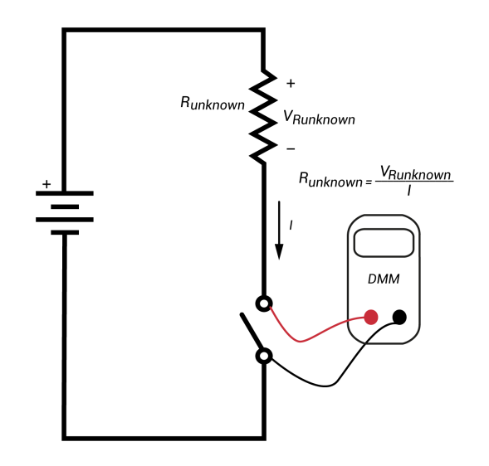For the first measurement, we want to calculate the current passing through the photoresistor. For this, the AVO should be connected in series with the resistor, and the power supply should be activated. This is shown in the diagram below:

Photoresistor

## The second measurement to be taken is measurement of the voltage across the resistor. Different from measuring resistance, for this measurement, the voltage source must be turned on. A diagram showing how to take the second measurement is shown below:

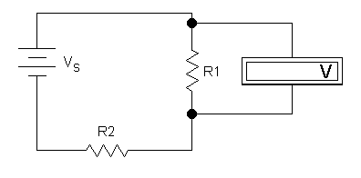

For this particular measurement, R2 can either be ignored or can be interpreted as the collective resistance of the wires and connections in the circuit. Regardless, it does not affect the measurement of voltage across R1.

## Results

A tabulated version of the results from this experiment is as follows:

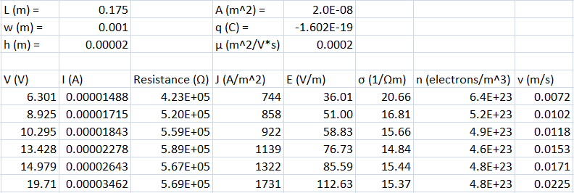

Shown on top is the measured physical properties of the wire (Length, width and height respectively) all measured in meters. To the right, three other constants are recorded. The first is the cross sectional area of the wire, which was calculated by multiplying width and height. Just below cross sectional area is the charge of an electron. This is measured in Coulombs (C). Below that is the mobility of electrons, which was given for this experiment. These 6 values are assumed to be constant throughout the duration of the experiment, and were present in the calculations of the material properties.

Below the constants are 6 iterations of the same experiment. Volatage and current were measured on the circuit, and from this current density, electric field, conductivity, drift velocity and density of free electrons were calculated using equations 1-5 respectively. Resistance is also shown. This is both for the convenience of creating the excel table, and to show variance of ambient light in each iteration. This is discussed more fully in the next section.

## Discussion

Ideally the resistance across the photoresistor would stay constant through the entire experiment. Maintaining a “dark” environment around the photoresistor is a little bit tricky in the lab, and the method used was to cover it with a hand. Unfortunately, this is not perfectly dark, and it is difficult to get the same light level every time. This is shown in the small variances in the values for resistance. Through the entire experiment, the resistance varied up to 16%, meaning the light level likely varied about that much. This makes it tough to speak to the accuracy of the electrical material properties, but the numbers should be relatively close to what one would see if they could create a consistent light level.

## Conclusion

Many of the results for the electrical material properties fall nicely where we would expect. Throughout the lab the current stayed in the order of μm, therefore one would expect a high resistance, which we see. Because of the small charge associated with a single electron, we would expect to see many electrons/m^3, which we see in the calculation of n (density of free electrons). We also see that the drift velocity is very slow, which is to be expected as this is the case for most simple circuit systems.

It was difficult to maintain perfectly the same ambient light conditions between iterations; this was shown in the calculation of resistance. Regardless of this, many electrical materials properties were calculated for a CdS semiconductor with decent accuracy in the measurements.